newbie:Users:roseanne:Desktop:*work in progress:fair and balanced policing:flyer:final flyer word version:FIP-bottom-bar.gif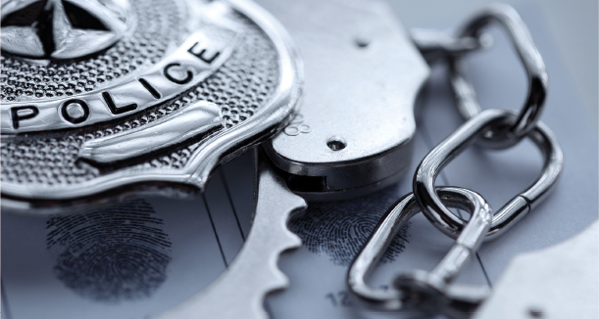newbie:Users:roseanne:Desktop:*work in progress:fair and balanced policing:flyer:final flyer word version:FIP-grey-bar.jpgnewbie:Users:roseanne:Desktop:*work in progress:fair and balanced policing:flyer:final flyer word version:FIP-blue-bar.jpg

**Eligibility**

You must be an experienced trainer employed by a law enforcement agency or training academy. At least two trainers, from each agency, should attend since the FIP curricula are team-taught. The sponsoring agency must be committed to training the FIP curricula following the TOT.

**Location:**

Pembroke Pines Training Facility

1201 SW 208 Ave

Pembroke Pines FL 33029

**Cost**: $675 per person

**For more information, contact:**

Ofc. Diana Alfin

[dalfin@ppines.com](mailto:dalfin@ppines.com)

954.517.7269

The **Fair & Impartial Policing** curricula is based on the science of implicit bias. Implicit biases can impact what people perceive and do, even in people who consciously hold non-prejudiced attitudes. The implication of the science of bias is that even the best law enforcement officers may manifest bias because they are human, and even the best agencies will have biased policing because they hire humans.

The FIP TOT allows teams of trainers to learn to implement both the patrol officers’ and first-line supervisors’ curricula. This

2- day TOT “walks” trainers through every aspect of the **FIP Training Program** and provides opportunities to practice teaching both curricula.

At the conclusion of the TOT, trainers will be able to:

• Understand and effectively communicate the science of implicit bias.

• Understand and effectively communicate that fair and impartial policing

leads to safe, effective and just policing.

• Use the **FIP Training** curricula to teach academy recruits and patrol

officers and first-line supervisors to: (1) recognize their conscious and

implicit biases and (2) implement skills to promote fair and impartial

policing in their daily work.

For more information, go to **www.fipolicing.com**

**TRAINING OF TRAINERS (TOT) PROGRAM:**

**July 28-29, 2021**

**Hosted by Pembroke Pines Police Department**